# Final Project

Trinath Kandula

W0461592

George Campanis

Applied Data Analytics

03/19/2023

# Final Business Case Documentation

**ERD**

**DFD (Level 0 and Level 1)**

**Data Dictionary**

**Code used to create your Database (DDL)**

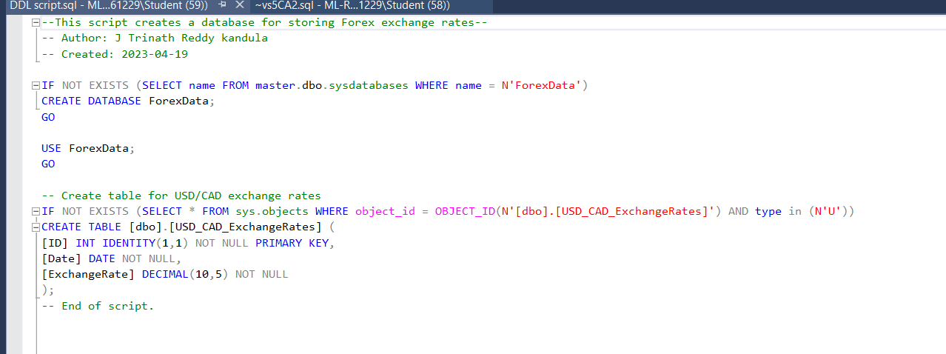

**Gantt Chart**

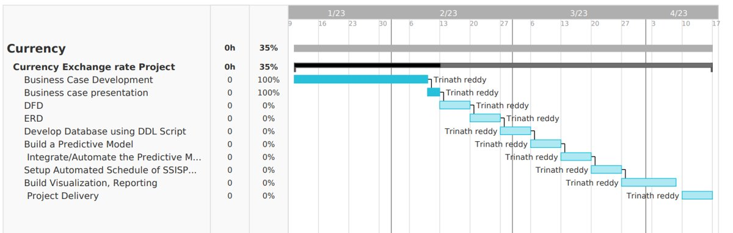

**Screenshots of MPowerBI and ML Code**

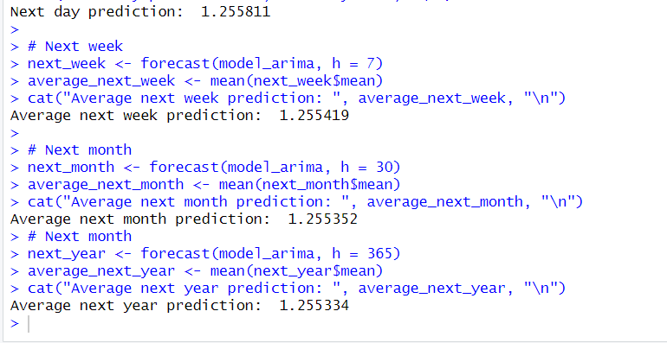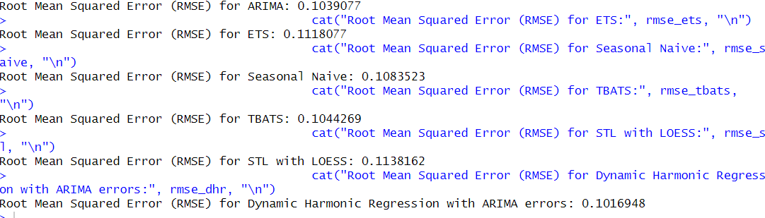

# MS SSIS Packages/Windows Schedule (png) for automating the following:

